MODERN SLAVERY AND HUMAN TRAFFICKING STATEMENT
The Modern Slavery Act 2015 requires any commercial organisation carrying out business in the UK with a total annual turnover of £36,000,000 or more to produce a slavery and human trafficking statement setting out the steps taken to ensure that modern slavery and human trafficking are not occurring within the organisation or its supply chain.
Story Contracting is a family-owned infrastructure company based in the North of England and Scotland providing construction, plant and rail solutions.
We fully support the principles and requirements of the Modern Slavery Act and aim to ensure that Story Contracting is compliant in relation to our employees and our supply chain.
Employees

We are committed to providing opportunities for employment and recruiting from within the communities in which we operate.

We value our staff and have high expectations of them. In return we aim to provide them with a safe, supportive and rewarding environment in which to develop and reach their full potential.

We are proud to be a Living Wage employer and pay a minimum of the Living Wage to our employees and require that our suppliers do the same.
We include information in our induction programme for new employees in relation to Modern Slavery and how to identify issues which may arise. We are working on training for existing employees and identifying and implementing a confidential process for reporting any related issues.
Supply Chain
Our supply chains include purchasing materials, sub-contracting, consultants, environmental and other associated trades and services connected with our industry.
We have thorough due diligence processes for managing our relationships with our sub-contractors and suppliers.
The obligations imposed by the Modern Slavery Act are clearly articulated in our agreements with sub-contractors and suppliers and compliance is required.
Our Policies
The policies which underpin this statement include:
- Recruitment and Selection Policy
- Employee Handbook
- Discipline Policy
- Grievance Policy
- Whistleblowing Policy
This statement will be reviewed annually.
Signed:
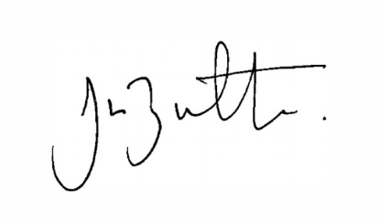
Jason Butterworth
Chief Executive
Date: 11 April 2017
