MODERN SLAVERY ACT TRANSPARENCY STATEMENT

Story Contracting is a family-owned infrastructure company based in the North of England and Scotland providing construction, plant and rail solutions.
We fully support the Modern Slavery Act 2015 and are committed to ensuring that Story Contracting is compliant with the requirements in relation to our employees and our supply chain.
We value our staff and have high expectations of them. In return we aim to provide them with a safe, supportive and rewarding environment in which to develop and reach their full potential.
We are proud to be a Living Wage employer and pay a minimum of the Living Wage to our staff and ensure that our suppliers do the same.
Our induction programme includes information for our staff in relation to Modern Slavery, how to identify issues which may arise and what action to take if they have any concerns.
We have a thorough due diligence process for managing our relationships with our sub-contractors and suppliers. We are reviewing our processes to ensure that the requirements of the Act are clearly articulated, where this is not already the case, and that our sub-contractors and suppliers agree to comply with those requirements.
This statement will be reviewed annually.
Signed:
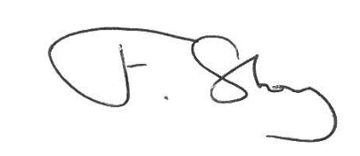
Fred Story
Chief Executive
Date: 6 January 2016

